EXP 9

1) SELECT last_name, hire_date FROM employees WHERE department_id = (SELECT department_id FROM employees WHERE last_name = 'Zlotkey') AND last_name <> 'Zlotkey';

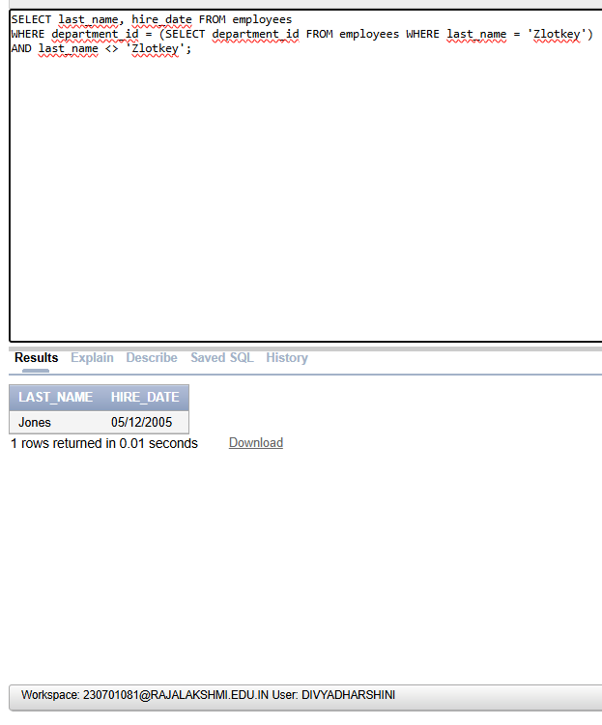

2) SELECT employee_id, last_name FROM employees

WHERE salary > (SELECT AVG(salary) FROM employees)

ORDER BY salary;

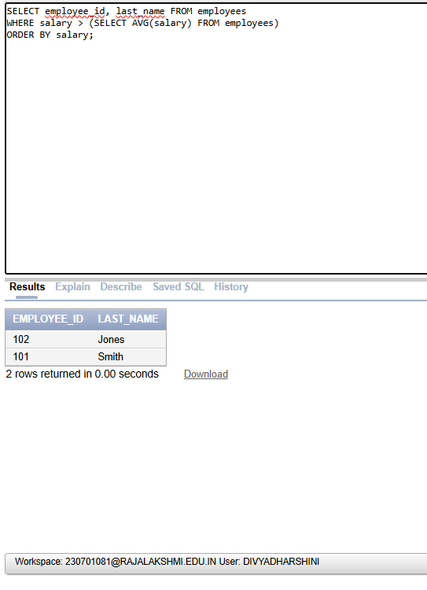

3) SELECT employee_id, last_name FROM employees

WHERE department_id IN (SELECT department_id FROM employees

WHERE last_name LIKE '%u%');

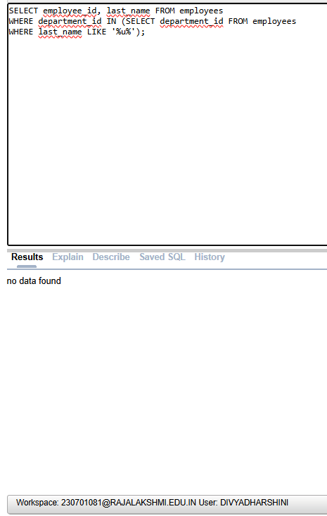

4) SELECT last_name, department_id, job_id FROM employees

WHERE department_id IN (SELECT department_id FROM departments

WHERE location_id = 1700);

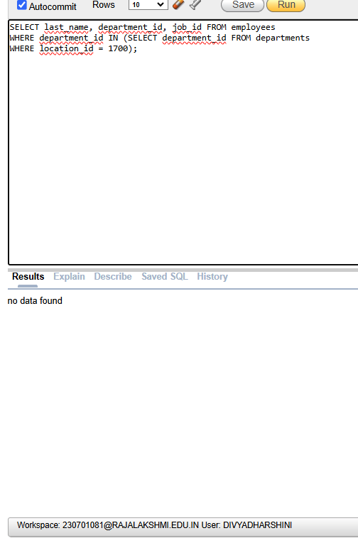

5) SELECT last_name, salary FROM employees

WHERE manager_id = (SELECT employee_id FROM employees WHERE last_name = 'King');

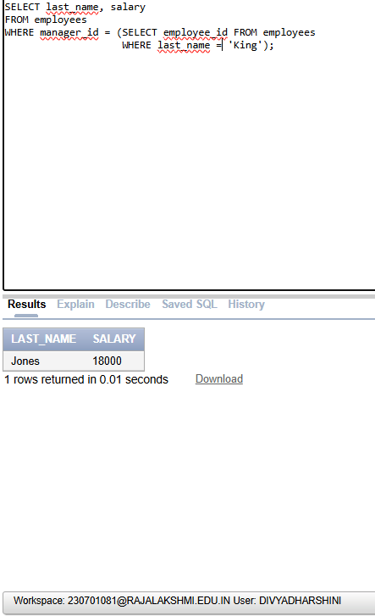

6) SELECT department_id, last_name, job_id

FROM employees

WHERE department_id IN (SELECT department_id FROM departments

WHERE department_name = 'Executive');

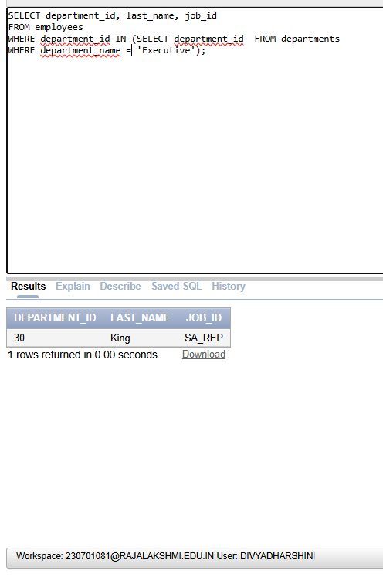

7) SELECT employee_id, last_name, salary FROM employees

WHERE department_id IN (SELECT department_id FROM employees

WHERE last_name LIKE '%u%') AND salary > (SELECT AVG(salary) FROM employees);

